Docker Task
Install docker on EC2 and explore the docker commands (docker images, containers, volumes, network)

Created EC2 instance:
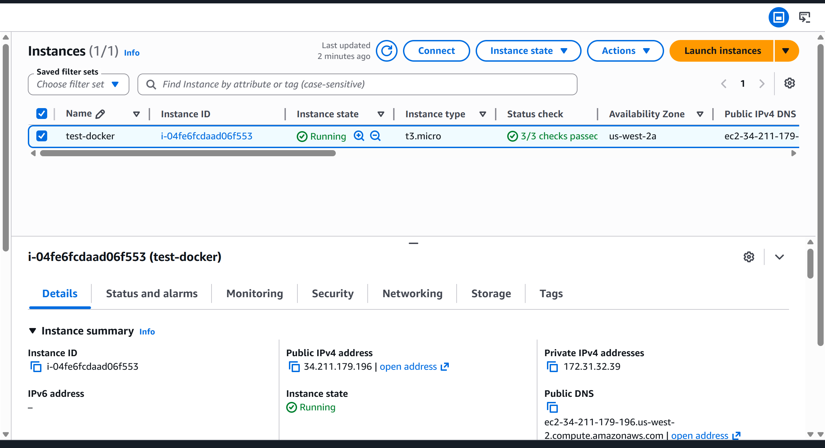
Docker Installation & setup:
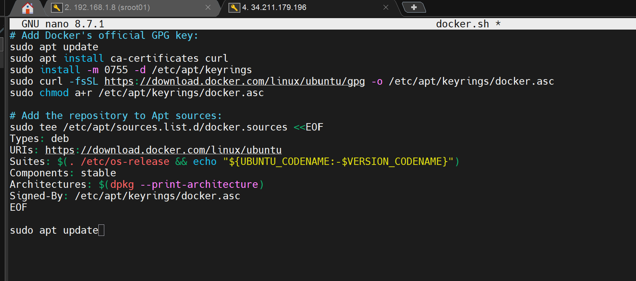

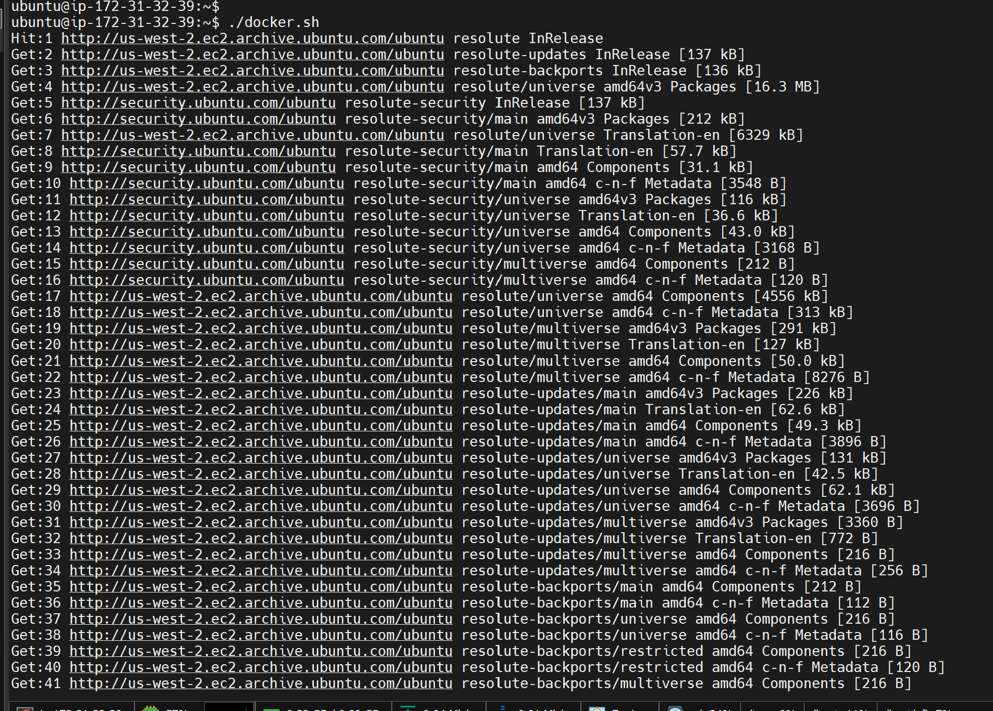

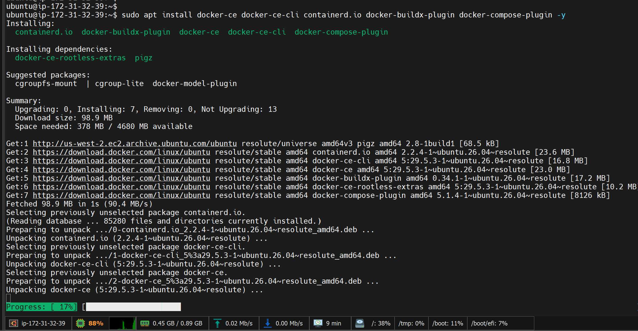

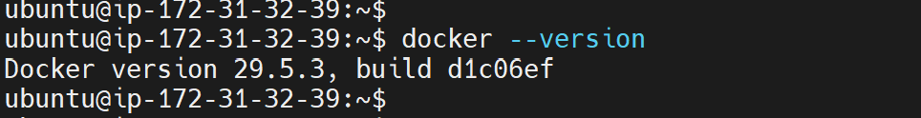
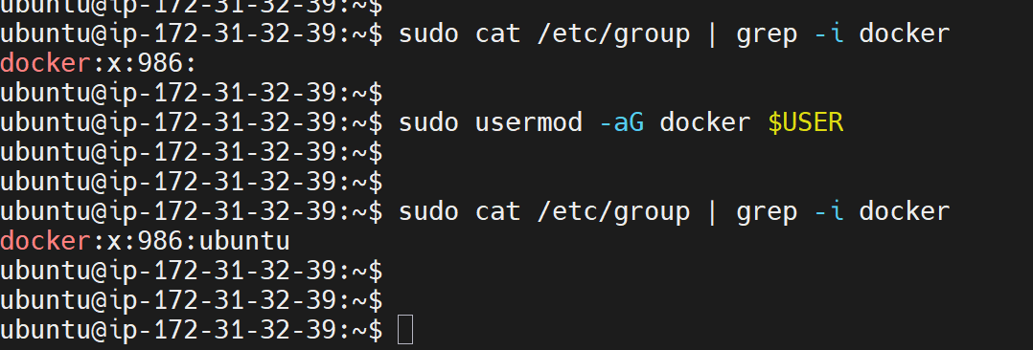
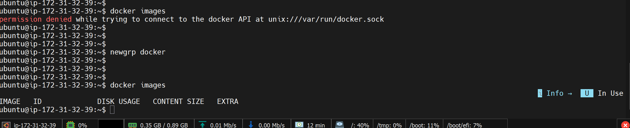
Pull container images apache2:

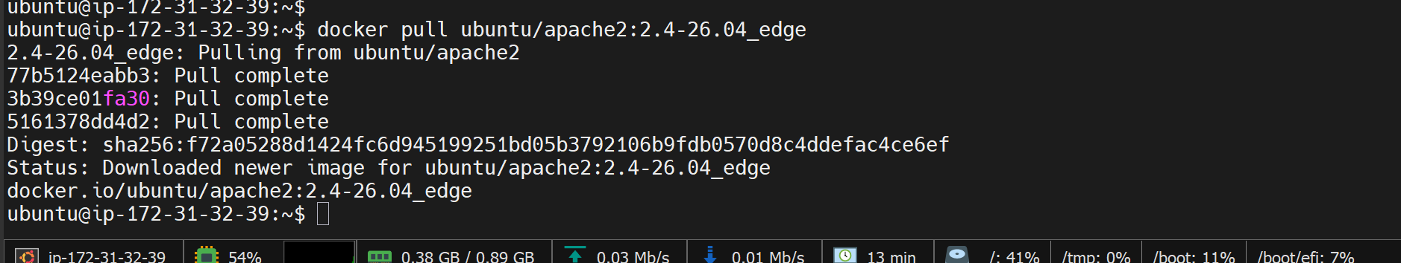

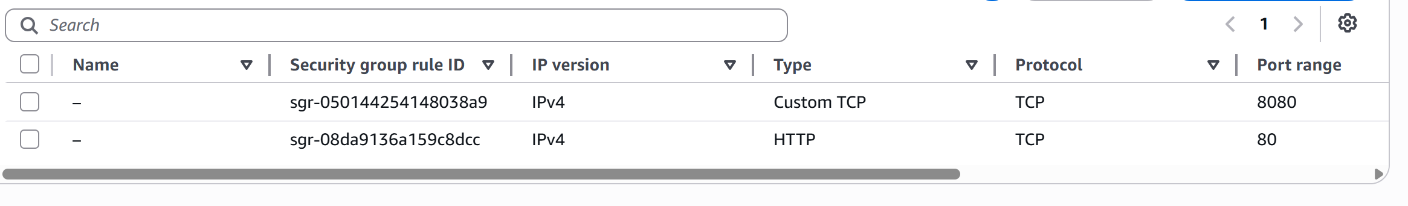

RUN Container:
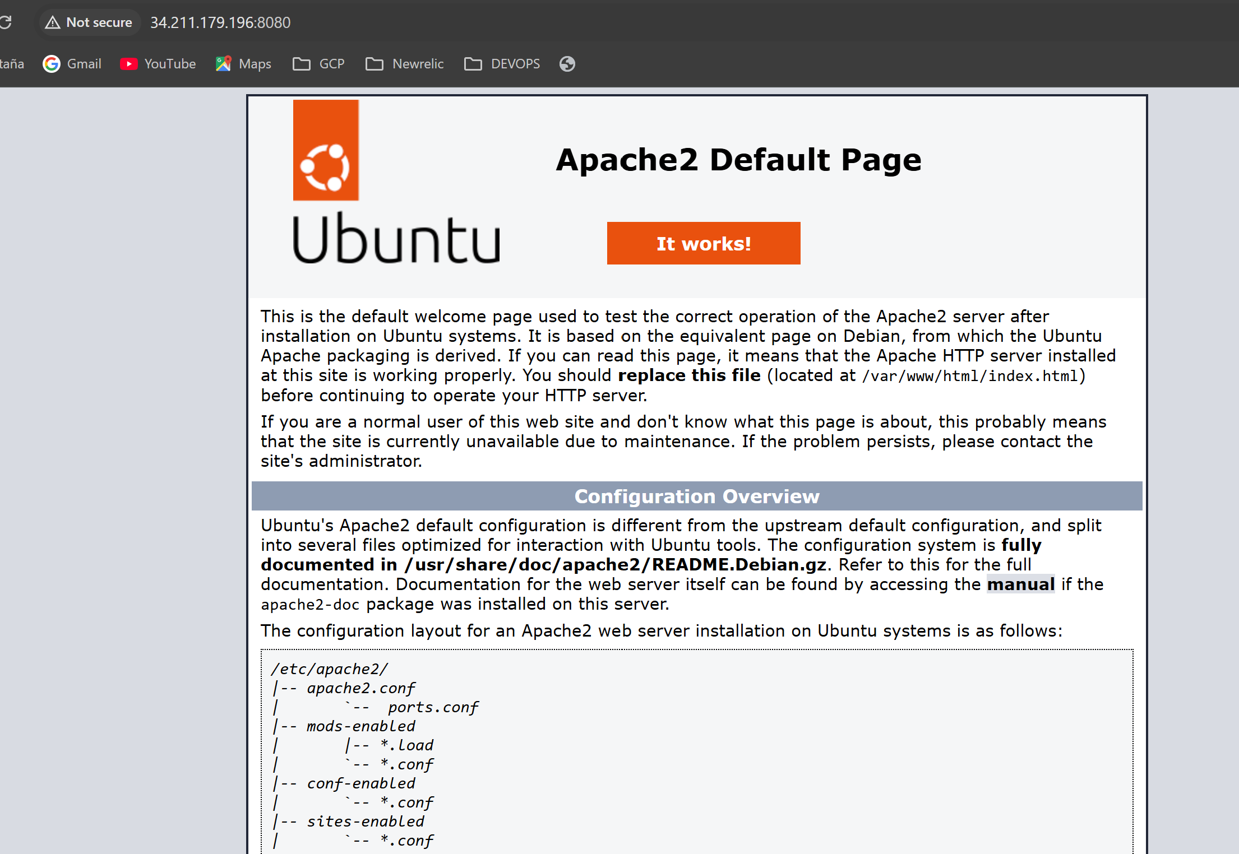
DOCKER VOLUME:
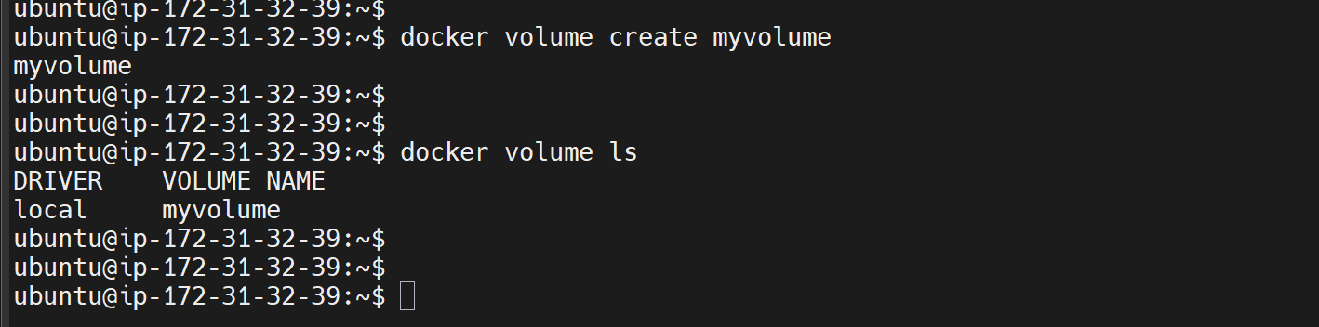
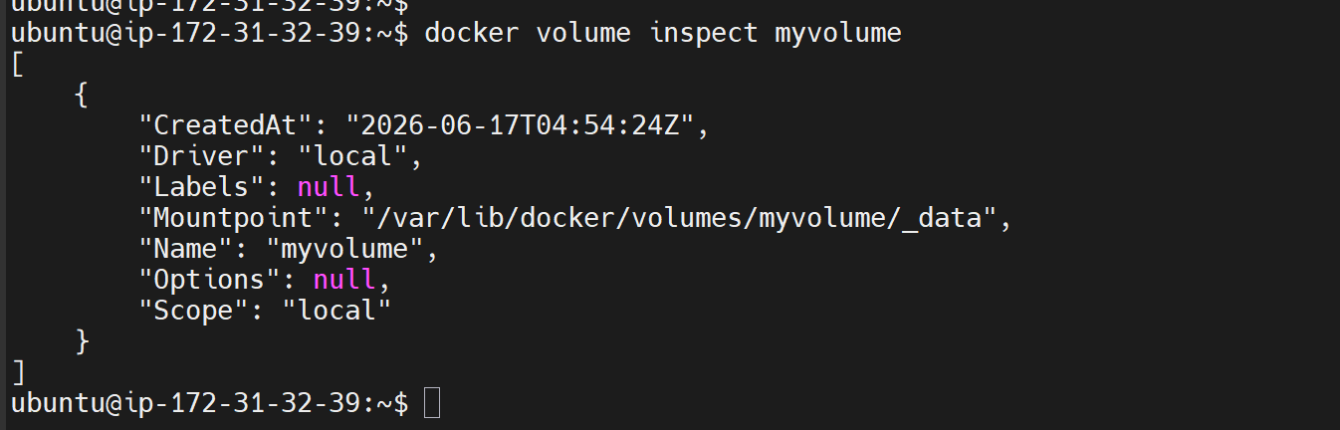

Run a Container Using the Volume:

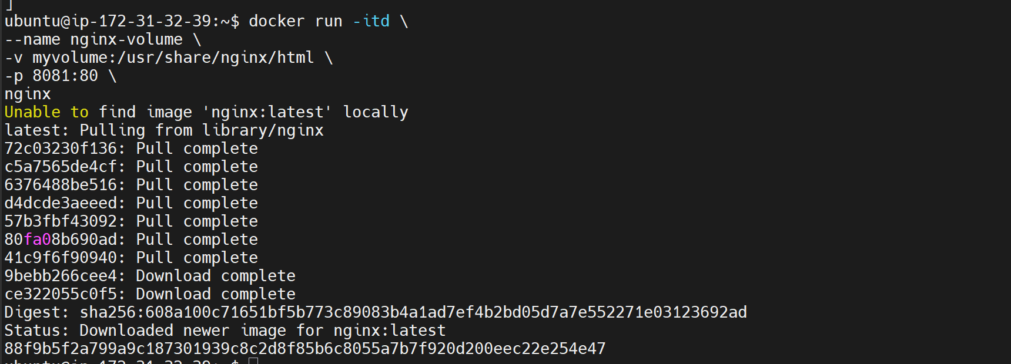

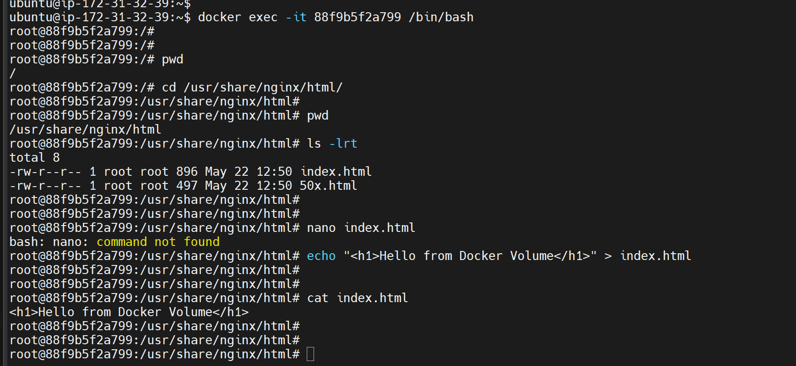

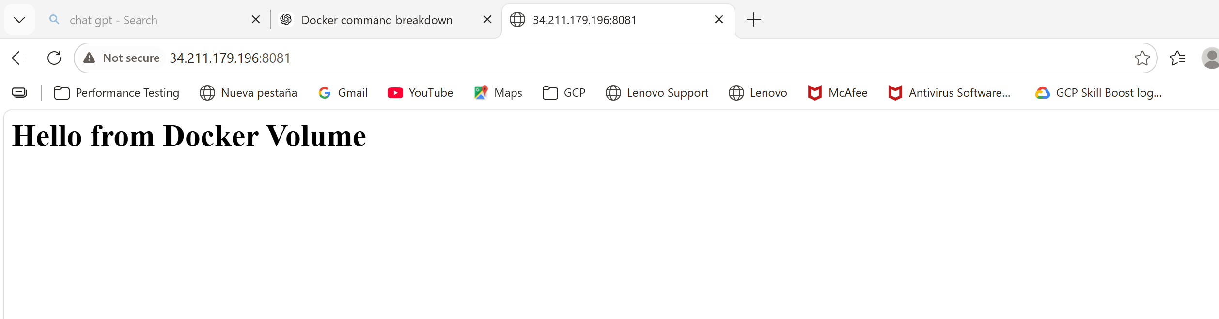

Docker Networks:

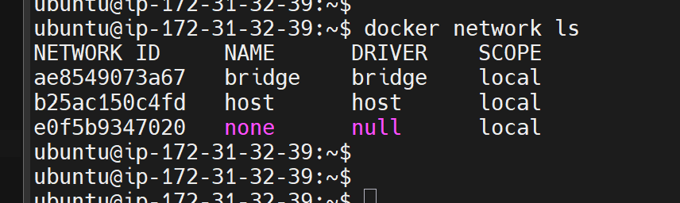

ubuntu@ip-172-31-32-39:~$ docker network inspect bridge
[
{
"Name": "bridge",
"Id": "ae8549073a6731ac64380148cc8fa97e2fae121e3cea7f10050df28688430da1",
"Created": "2026-06-17T04:43:36.59598914Z",
"Scope": "local",
"Driver": "bridge",
"EnableIPv4": true,
"EnableIPv6": false,
"IPAM": {
"Driver": "default",
"Options": null,
"Config": [
{
"Subnet": "172.17.0.0/16",
"Gateway": "172.17.0.1"
}
]
},
"Internal": false,
"Attachable": false,
"Ingress": false,
"ConfigFrom": {
"Network": ""
},
"ConfigOnly": false,
"Options": {
"com.docker.network.bridge.default_bridge": "true",
"com.docker.network.bridge.enable_icc": "true",
"com.docker.network.bridge.enable_ip_masquerade": "true",
"com.docker.network.bridge.host_binding_ipv4": "0.0.0.0",
"com.docker.network.bridge.name": "docker0",
"com.docker.network.driver.mtu": "1500"
},
"Labels": {},
"Containers": {
"88f9b5f2a799a9c187301939c8c2d8f85b6c8055a7b7f920d200eec22e254e47": {
"Name": "nginx-volume",
"EndpointID": "7e3052c009bef252ccc761dd47efc236f2cebbdca1be3c6cff6bd40b7c788ed6",
"MacAddress": "4e:18:4f:1e:9e:81",
"IPv4Address": "172.17.0.3/16",
"IPv6Address": ""
},
"db86b111bb37e389c1966f4ae35ad1c3834d7c11e4fc1c9df7e1dbf845d11dd4": {
"Name": "test-container01",
"EndpointID": "989b2fb33692ccb3aae01bfb8db8e1f761fdf8185ed96228de6eab912ee1563e",
"MacAddress": "aa:9c:0f:41:97:87",
"IPv4Address": "172.17.0.2/16",
"IPv6Address": ""
}
},
"Status": {
"IPAM": {
"Subnets": {
"172.17.0.0/16": {
"IPsInUse": 5,
"DynamicIPsAvailable": 65531
}
}
}
}
}
]
ubuntu@ip-172-31-32-39:~$

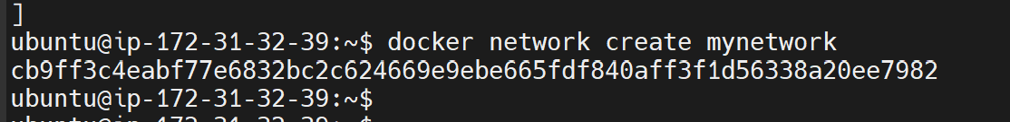

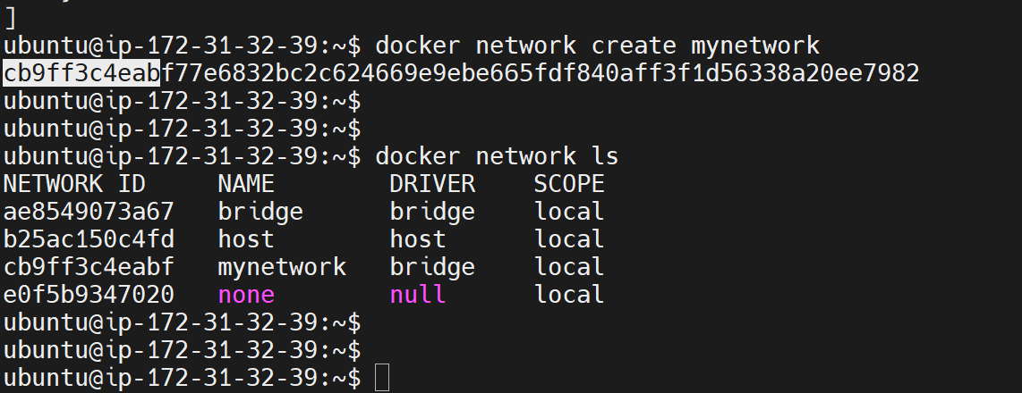

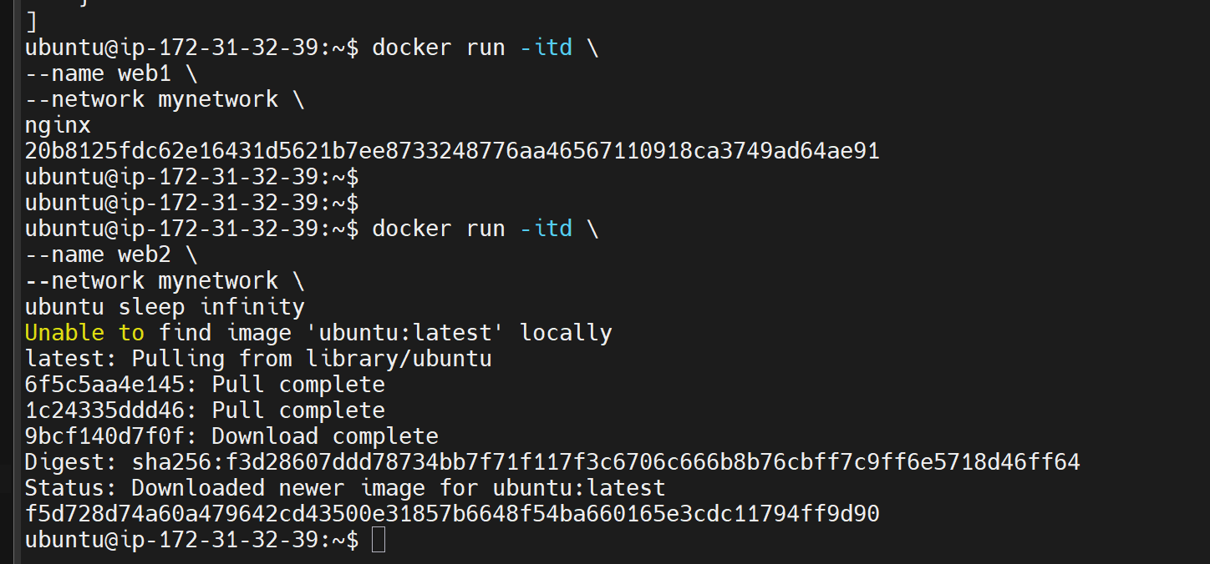

Inspect network after container creation:

